# Appendix A: estimation of Effective strip half width

To estimate effective strip half width (esw), detection probability was modelled for each of the three species including the evaluation of covariates that might affect detection. Models were fitted in packages ‘Distance’ (version 0.9.7.; Miller, 2017) and ‘mrds’ (version 2.1.18.; Laake, Borchers, Thomas, Miller, & Bishop, 2017) in R (version 3.4.3.; R Core Team, 2021). For each species, truncation of the perpendicular distance data prior to modelling detection probability was investigated. Selection among models at different truncation distances was done using the unweighted Cramer-von Mises goodness of fit test.

Key detection functions evaluated were the half-normal and the hazard rate. Covariates evaluated were Beaufort (original data or grouped into fewer levels, e.g. Beaufort(2), Beaufort(3)) and vessel.

Following any truncation of the data, the best models were selected using Akaike’s Information Criterion (AIC). Q-Q plots and the results of the unweighted Cramer-von Mises test were also inspected. If the difference in AIC between models was less than 2 units and both models seemed adequate, the simplest model with fewest parameters was chosen.

The best models of detection probability for each species for the Iceland-Faroes data 1987-2015, the Norwegian data for 1987-1989, and the Norwegian data for 1995-2013 were used to estimate effective strip half width (esw) to be used to calculate effective search area.

**Sperm whales**

**Effective strip half width – Iceland-Faroes 1987-2015**

The best detection function for the sperm whale in the 1987-2015 Iceland and Faroese data was a half normal model with a 3,000 m truncation distance which included 564 sightings (Table A‑1). Only vessel ID (ten levels) was retained in the selected model. The fitted model is shown in Figure A‑2. The model fitted the data well as shown in the Q-Q plot (Figure A‑2) and by the Cramer‑von Mises goodness of fit test [unweighted] p = 0.148. The average probability of detection, p, was 0.581 (CV = 0.036). The estimated effective strip half width for the ten covariate levels is given in Table A‑3.

Table A‑1. HR= hazard-rate, HN= Half-normal. p = average probability of detection, No. obs= number of observations, CV= coefficient of variation, SE= standard error, Goodness of fit= Cramer-von Mises. Best models are in bold.

|  |  |  |  |  |  |  |  |  |  |  |
| --- | --- | --- | --- | --- | --- | --- | --- | --- | --- | --- |
| Species | Truncation | Key function | Covariates | No. obs | p | CV | SE | Goodness of fit (p‑value) | AIC | Survey & Period |
| Sperm whale | 3,000 | HR | ~1 | 564 | 0.502 | 0.081 | 0.041 | 0.766 | 8,887.088 | Iceland-Faroes 1987-2015 |
| HN | ~1 | 0.603 | 0.034 | 0.021 | 0.031 | 8,894.313 |
| HR | ~group size | 0.512 | 0.077 | 0.040 | 0.785 | 8,886.642 |
| HN | ~group size | 0.601 | 0.034 | 0.021 | 0.036 | 8,893.063 |
| HR | ~ vessel ID | 0.584 | 0.055 | 0.032 | 0.225 | 8,885.596 |
| HN | ~ vessel ID | 0.581 | 0.036 | 0.021 | 0.148 | 8,876.979 |
| HR | ~beaufort(3) | 0.500 | 0.081 | 0.040 | 0.712 | 8,887.533 |
| HN | ~beaufort(3) | 0.601 | 0.034 | 0.021 | 0.036 | 8,895.100 |
| HR | ~group size + vessel ID | 0.583 | 0.054 | 0.032 | 0.239 | 8,885.627 |
| HN | ~group size + vessel ID | 0.579 | 0.036 | 0.021 | 0.162 | 8,877.658 |
| HR | ~vessel ID + beaufort(3) | 0.584 | 0.054 | 0.031 | 0.244 | 8,885.004 |
| HN | ~vessel ID + beaufort(3) | 0.578 | 0.036 | 0.021 | 0.178 | 8,878.283 |
| HR | ~group size + vessel ID + beaufort(3) | 0.584 | 0.054 | 0.031 | 0.244 | 8,885.004 |
| HN | ~group size + vessel ID + beaufort(3) | 0.578 | 0.036 | 0.021 | 0.178 | 8,878.283 |
| Pilot whale | 1,800 | HR | ~1 | 558 | 0.281 | 0.095 | 0.027 | 0.675 | 8,022.528 | Iceland-Faroes 1987-2015 |
| HN | ~1 | 0.501 | 0.028 | 0.014 | 0.000 | 8,100.886 |
| HR | ~group size | 0.278 | 0.095 | 0.027 | 0.740 | 8,023.374 |
| HN | ~group size | 0.497 | 0.028 | 0.014 | 0.000 | 8,091.851 |
| HR | ~ vessel ID | 0.192 | 0.159 | 0.030 | 0.461 | 8,020.285 |
| HN | ~ vessel ID | 0.484 | 0.029 | 0.014 | 0.000 | 8,086.011 |
| HR | ~beaufort(2) | 0.296 | 0.086 | 0.026 | 0.577 | 7,999.264 |
| HN | ~beaufort(2) | 0.485 | 0.028 | 0.014 | 0.000 | 8,067.430 |
| HR | ~group size + vessel ID | 0.191 | 0.158 | 0.030 | 0.500 | 8,021.757 |
| HN | ~group size + vessel ID | 0.480 | 0.029 | 0.014 | 0.000 | 8,077.174 |
| HR | ~vessel ID + beaufort(2) | 0.270 | 0.098 | 0.026 | 0.660 | 8,067.430 |
| HN | ~vessel ID + beaufort(2) | 0.470 | 0.029 | 0.014 | 0.000 | 8,056.636 |
| HR | ~group size + beaufort(2) | 0.293 | 0.087 | 0.025 | 0.616 | 7,999.636 |
| HN | ~group size + beaufort(2) | 0.480 | 0.028 | 0.014 | 0.000 | 8,057.701 |
| Northern bottlenose whale | 2,000 | HR | ~1 | 313 | 0.269 | 0.144 | 0.039 | 0.598 | 4,595.549 | Iceland-Faroes 1987-2015 |
| HN | ~1 | 0.525 | 0.040 | 0.021 | 0.000 | 4,631.242 |
| HR | ~group size | 0.266 | 0.146 | 0.039 | 0.577 | 4,596.797 |
| HN | ~group size | 0.525 | 0.041 | 0.021 | 0.000 | 4,632.321 |
| HR | ~ vessel ID | 0.219 | 0.267 | 0.058 | 0.715 | 4,590.275 |
| HN | ~ vessel ID | 0.500 | 0.044 | 0.022 | 0.000 | 4,624.237 |
| HR | ~beaufort(3) | 0.219 | 0.267 | 0.058 | 0.715 | 4,590.275 |
| HN | ~beaufort(3) | 0.500 | 0.044 | 0.022 | 0.000 | 4,624.237 |
| HR | ~group size + vessel ID | 0.217 | 0.264 | 0.057 | 0.694 | 4,591.730 |
| HN | ~group size + vessel ID | 0.498 | 0.046 | 0.023 | 0.000 | 4,624.134 |
| HR | ~vessel ID + beaufort(3) | 0.226 | 0.261 | 0.059 | 0.784 | 4,587.811 |
| HN | ~vessel ID + beaufort(3) | 0.494 | 0.044 | 0.022 | 0.000 | 4,622.457 |
| HR | ~group size + beaufort(3) | 0.257 | 0.150 | 0.039 | 0.695 | 4,596.333 |
| HN | ~group size + beaufort(3) | 0.519 | 0.042 | 0.022 | 0.000 | 4,628.629 |
| Sperm whale | 2,000 | HR | ~1 | 107 | 0.386 | 0.174 | 0.067 | 0.691 | 1,578.432 | Norway 1987‑1989 |
| HN | ~1 | 0.506 | 0.070 | 0.035 | 0.154 | 1,578.996 |
| HR | ~ vessel ID | 0.418 | 0.148 | 0.062 | 0.795 | 1,575.770 |
| HN | ~ vessel ID | 0.498 | 0.070 | 0.035 | 0.218 | 1,580.026 |
| Sperm whale | 3,000 | HR | ~1 | 814 | 0.410 | 0.042 | 0.017 | 0.576 | 12,475.421 | Norway 1995‑2013 |
| HN | ~1 | 0.441 | 0.024 | 0.010 | 0.007 | 12,482.255 |
| HR | ~1 | 813 | 0.409 | 0.042 | 0.017 | 0.570 | 12,460.695 | Norway 1995‑2013 |
| HN | ~1 | 0.441 | 0.024 | 0.011 | 0.006 | 12,467.460 |
| HR | ~group size | 0.409 | 0.042 | 0.017 | 0.572 | 12,462.675 |
| HN | ~group size | 0.441 | 0.024 | 0.011 | 0.006 | 12,469.457 |
| HR | ~ vessel ID | 0.409 | 0.042 | 0.017 | 0.489 | 12,462.550 |
| HN | ~ vessel ID | 0.439 | 0.024 | 0.011 | 0.009 | 12,465.606 |
| HR | ~beaufort | 0.411 | 0.042 | 0.017 | 0.533 | 12,469.514 |
| HN | ~beaufort | 0.438 | 0.026 | 0.012 | 0.010 | 12,473.947 |
| Pilot whale | No truncation | HR | ~1 | 35 | 0.396 | 0.307 | 0.122 | 0.991 | 481.557 | Norway 1995‑2013 |
| HN | ~1 | 0.532 | 0.116 | 0.062 | 0.398 | 482.396 |
| HR | ~group size | 0.346 | 0.369 | 0.128 | 0.967 | 483.811 |
| HN | ~group size | 0.531 | 0.122 | 0.065 | 0.391 | 484.340 |
| HR | ~ vessel ID | 0.521 | 0.126 | 0.066 | 0.410 | 474.088 |
| HN | ~ vessel ID | 0.402 | 0.214 | 0.086 | 0.629 | 471.762 |
| HR | ~beaufort(3) | 0.484 | 0.095 | 0.046 | 0.845 | 465.250 |
| HN | ~beaufort(3) | 0.361 | 0.197 | 0.071 | 0.586 | 465.359 |
| Northern bottlenose whale | No truncation | HR | ~1 | 48 | 0.286 | 0.235 | 0.067 | 0.822 | 679.246 | Norway 1995‑2013 |
| HN | ~1 | 0.460 | 0.079 | 0.036 | 0.029 | 688.102 |
| HR | ~pod.best.av | 0.348 | 0.199 | 0.069 | 0.667 | 680.345 |
| HN | ~pod.best.av | 0.443 | 0.081 | 0.036 | 0.053 | 686.834 |
| HR | ~beaufort(2) | 0.248 | 0.273 | 0.068 | 0.885 | 678.015 |
| HN | ~beaufort(2) | 0.460 | 0.082 | 0.038 | 0.030 | 690.089 |
| HR | ~vessel ID | 0.279 | 0.226 | 0.063 | 0.781 | 679.403 |
| HN | ~vessel ID | 0.445 | 0.111 | 0.049 | 0.045 | 689.095 |

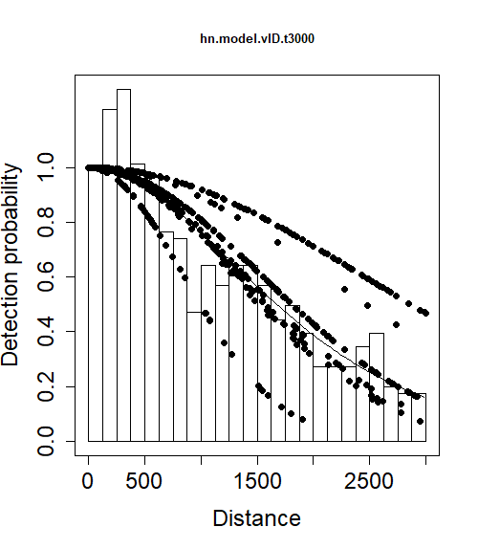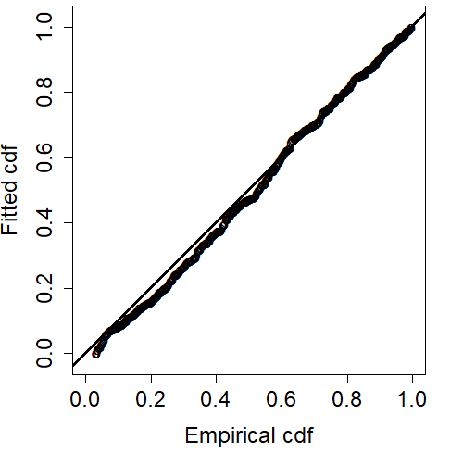

Figure A‑2. Detection probability (left) and Q-Q (right) plots for sperm whale 1987-2015 Iceland‑Faroes data. For detection probability, the circles represent fitted values of the data, the line is the fitted model and the frequency histogram represents the observed data. In the Q-Q plot (right) the points are the fitted values while the solid line represents a perfect fit.

Table A‑3. ESW, effective strip half width, for Iceland-Faroes sperm whale data at each level of the covariate vessel. Vessel ID is given as an abbreviation of the vessel’s name.

|  |  |
| --- | --- |
| Vessel (ID) | ESW (m) |
| F | 1,646.23 |
| G | 1,838.29 |
| K | 2,532.53 |
| S | 1,687.20 |
| I | 1,641.14 |
| J | 1,597.46 |
| A | 2,385.41 |
| B | 2,225.18 |
| V | 1,828.04 |
| H | 1,055.01 |

**Effective strip half width – Norway 1987-1989**

The best detection function for the sperm whale in the 1987-1989 Norwegian data was a hazard rate model with a 2,000 m truncation distance, which included a total of 107 sightings (Table A‑1). Vessel ID (three levels) was retained in the selected model. The fitted model is shown in Figure A-4. As shown in the Q-Q plot (Figure A-4) and by the Cramer-von Mises goodness of fit test [unweighted] p = 0.795, the model fitted the data well. The average probability of detection, p, was 0.418 (CV = 0.148). The estimated effective strip half width for the three-covariate levels is given in Table A-5.

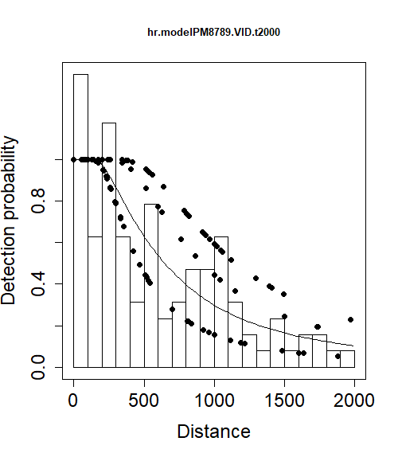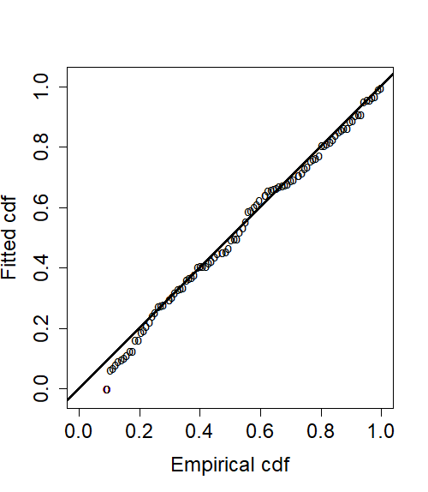

Figure A-4. Detection probability (left) and Q-Q (right) plots for sperm whale 1987-1989 Norwegian data. For detection probability, the circles represent fitted values of the data, the line is the fitted model and the frequency histogram represents the observed data. In the Q-Q plot (right) the points are the fitted values while the solid line represents a perfect fit.

Table A-5. ESW, effective strip half width for Norwegian 1987-1989 sperm whales at each level of the covariate vessel. Vessel ID is given as the number of the vessel’s grouping based on vessel size.

|  |  |
| --- | --- |
| Vessel (ID) | ESW (m) |
| 1 | 627.98 |
| 2 | 1,073.26 |
| 3 | 1,256.29 |

### **Effective strip half width – Norway 1995-2013**

The best detection function for the sperm whale in the 1995-2013 Norwegian data was a hazard rate model with a 3,000 m truncation distance which included a total of 814 sightings (Table A‑1). No variables were retained in the selected model. The fitted model is shown Figure A-6. The model fitted the data well as shown in the Q-Q plot (Figure A-6) and by the **Cramer‑von Mises goodness of fit test [unweighted] p = 0.576. The average probability of** detection, p, was 0.41 (CV = 0.042). The estimated effective strip half width was 1,230 m.

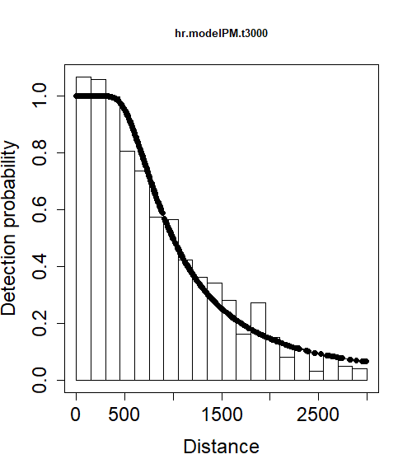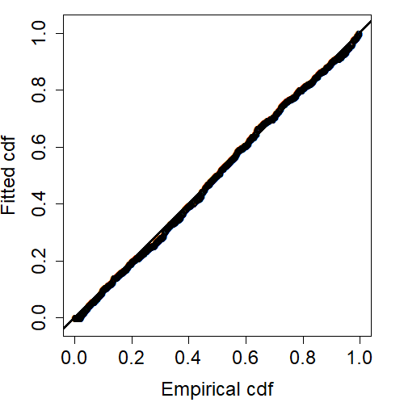

Figure A-6. Detection probability (left) and Q-Q (right) plots for sperm whale 1995-2013 Norwegian data. For detection probability, the circles represent fitted values of the data, the line is the fitted model and the frequency histogram represents the observed data. In the Q-Q plot (right) the points are the fitted values while the solid line represents a perfect fit.

### **Pilot whales**

### **Effective strip half width – Iceland-Faroes 1987-2015**

The best detection function for the long‑finned pilot whale in the 1987-2015 Iceland‑Faroes data was a hazard rate model with a 1,800 m truncation distance which included 558 sightings (Table A‑1). Only Beaufort (two levels) was retained in the selected model. The fitted model is shown in Figure A-7. The model fitted the data well as shown in the Q-Q plot Figure A-7 and by the Cramer‑von Mises goodness of fit test [unweighted] p = 0.577. The average probability of detection, p, was 0.296 (CV = 0.086). The estimated effective strip half width for the two covariate levels is given in Table A-8.

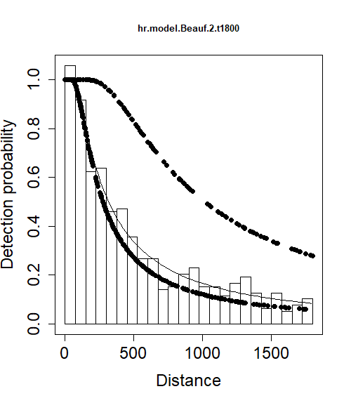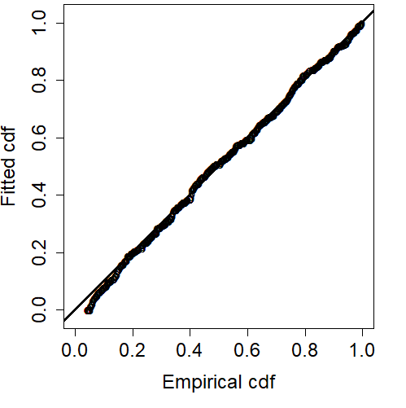

Figure A-7. Detection probability (left) and Q-Q (right) plots for long‑finned pilot whale 1987-2015 Iceland‑Faroes data. For detection probability, the circles represent fitted values of the data, the line is the fitted model and the frequency histogram represents the observed data. In the Q-Q plot (right) the points are the fitted values while the solid line represents a perfect fit.

Table A-8. ESW, effective strip half width for the Iceland‑Faroes long‑finned pilot whales at the two Beaufort levels: high (H), and low (L).

|  |  |
| --- | --- |
| Beaufort | ESW (m) |
| H | 457.64 |
| L | 1,095.07 |

#### 

### **Effective strip half width – Norway 1995-2013**

The best detection function for the long‑finned pilot whale in the 1995‑2013 Norwegian data was a hazard rate model including a total of 35 sightings (Table A‑1). Beaufort (three levels) was retained in the selected model. The fitted model is shown in plots Figure A-9. The model fitted the data fairly well, as shown by the Q-Q plot (Figure A-9) and by the Cramer-von Mises goodness of fit test [unweighted] p = 0.845. The average probability of detection, p, was 0.484 (CV = 0.095). The estimated effective strip half width for the three covariate levels is given in Table A-10.

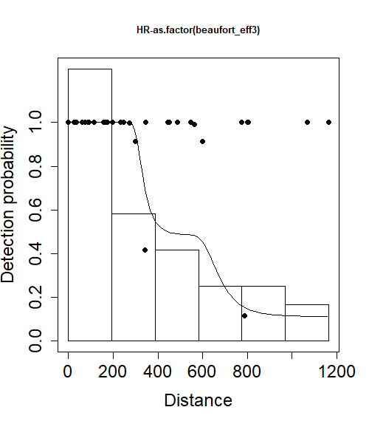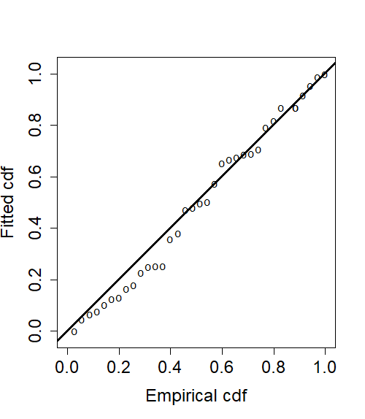

Figure A-9. Detection probability (left) and Q-Q (right) plots for long‑finned pilot whale 1995-2013 Norwegian data. For detection probability, the circles represent fitted values of the data, the line is the fitted model and the frequency histogram represents the observed data. In the Q-Q plot (bottom) the points are the fitted values while the solid line represents a perfect fit.

Table A-10. ESW, effective strip half width for the Norwegian 1995-2013 long‑finned pilot whales at the three Beaufort levels: high (H), medium (M) and low (L).

|  |  |
| --- | --- |
| Beaufort | ESW (m) |
| H | 343.76 |
| M | 690.04 |
| L | 1,164.36 |

### 

### **Northern bottlenose whales**

### **Effective strip half width – Iceland-Faroes 1987-2015**

The best detection function for the northern bottlenose whale in the 1987-2015 Iceland‑Faroes data was a hazard rate model with a 2,000 m truncation distance which included 313 sightings (Table A‑1). Two factor covariates were retained in the selected model: vessel (ten levels) and Beaufort (three levels). The fitted model is shown in Figure A-11. The model fitted the data well as shown in the Q-Q plot (Figure A-11) and the Cramer-von Mises goodness of fit test [unweighted] p = 0.784. The average probability of detection, p, was 0.226 (CV = 0.261). The estimated effective strip half width for all combinations of covariate levels is given in Table A-12.

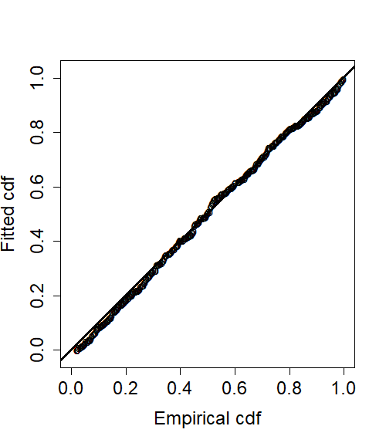

Figure A-11. Detection probability (left) and Q-Q (right) plots for northern bottlenose whale 1987‑2015 Iceland‑Faroes data. For detection probability, the circles represent fitted values of the data, the line is the fitted model and the frequency histogram represents the observed data. In the Q-Q plot (right) the points are the fitted values while the solid line represents a perfect fit.

Table A-12. ESW, effective strip half width for the Iceland‑Faroes northern bottlenose whales for each covariate/level combination. Levels of the covariate vessel ID relate to the abbreviation of the vessel’s name. Covariate Beaufort has three levels: high (H), medium (M) and low (L).

|  |  |  |  |  |  |  |
| --- | --- | --- | --- | --- | --- | --- |
| Vessel (ID) | Beaufort | ESW (m) |  | Vessel (ID) | Beaufort | ESW (m) |
| A | H | 842.86 | I | H | 417.72 |
| A | L | 1,702.62 | I | L | 1,109.12 |
| A | M | 1,102.33 | I | M | 581.76 |
| B | H | 42.69 | J | H | 523.25 |
| B | L | 152.68 | J | L | 1,297.50 |
| B | M | 63.74 | J | M | 717.55 |
| F | H | 426.79 | K | H | 470.97 |
| F | L | 1,126.50 | K | L | 1,207.93 |
| F | M | 593.59 | K | M | 650.81 |
| G | H | 790.51 | S | H | 312.39 |
| G | L | 1,651.55 | S | L | 889.76 |
| G | M | 1,042.14 | S | M | 442.05 |
| H | H | 283.06 | V | H | 609.57 |
| H | L | 822.64 | V | L | 1,430.10 |

### **Effective strip half width – Norway 1995-2013**

The best detection function for the northern bottlenose whale in the 1995-2013 Norwegian data was a hazard rate model without additional covariates fitted to untruncated data including a total of 48 sightings (Table A‑1). The model fitted the data well as shown in the Q-Q plot (Figure A-13) and the Cramer-von Mises goodness of fit test [unweighted] p = 0.822. The average probability of detection, p, was 0.286 (CV = 0.235). The estimated effective strip half width was 494 m.

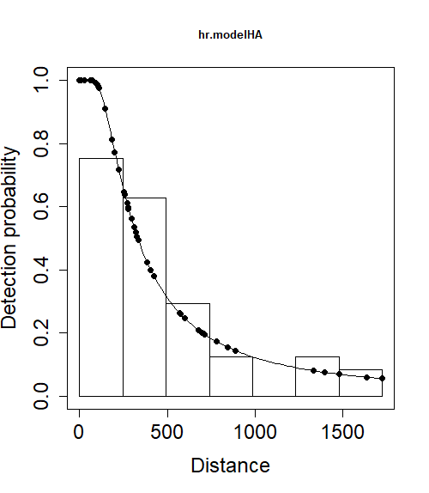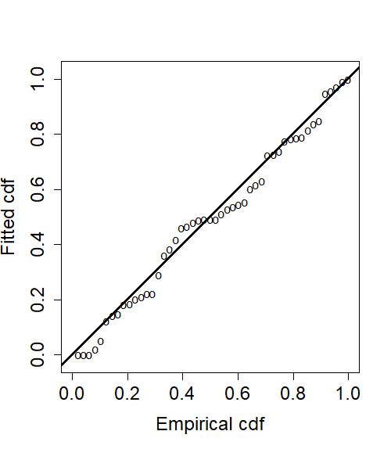

Figure A-13. Detection probability (left) and Q-Q (right) plots for northern bottlenose whale 1995‑2013 Norwegian data. For detection probability, the circles represent fitted values of the data, the line is the fitted model and the frequency histogram represents the observed data. In the Q-Q plot (bottom) the points are the fitted values while the solid line represents a perfect fit.

# REFERENCES

Laake, J., Borchers, D. L., Thomas, L., Miller, D. L., & Bishop, J. (2017). mrds: Mark-Recapture Distance Sampling. version 2.1.18. https://cran.r-project.org/package=mrds. Retrieved from https://cran.r-project.org/package=mrds

Miller, D. L. (2017). Distance: Distance sampling detection function and abundance estimation. version 0.9.7. http://cran.r-project.org/package=Distance. Retrieved from http://cran.r-project.org/package=Distance

R Core Team. (2021). R: A Language and Environment for Statistical Computing. Vienna, Austria: R Foundation for Statistical Computing.